Christmas in Kenilworth – a Toolkit for businesses

We would love you to get involved in our campaign to Shop Local, Eat Local and Spend Local. This is how you can join in.
Social Media Campaign
Kenilworth Chamber of Trade will be running Shop Local, Eat Local and Spend Local campaign on social media (Facebook, Instagram, Twitter and even LinkedIn).
There are a number of stories we will want you to get involved in, so start following us today and do join in. We’ve put together a tick list and examples of how you can do just that.
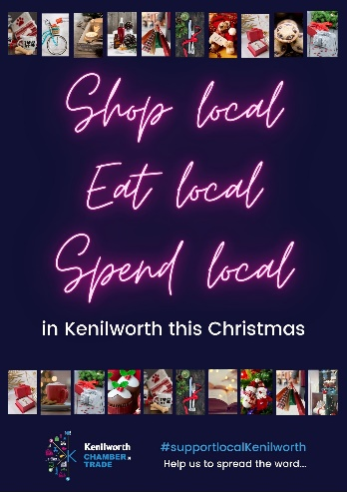
Support Local Posters
With our toolkit you will receive a shop window poster promoting the local message for you to display prominently in your window.
The Faces Behind the Business
The Chamber of Trade team will be out and about in town with some marketing props to promote the #supportlocalkenilworth hashtag. We’ll invite you to pose for a picture for us to post on social media to promote your business and the local message.
Online Retail Therapy Events
These online events are free for people to attend and there will be no charge for retailers to take part! A number of local retailers will be showcasing a small selection of their products which viewers can order from the comfort of their own home.
We have confirmed bookings for retailers taking part, but we do have limited availability for more to join. If you’ve not already expressed an interest in taking part, email chair@kenilworthchamber.co.uk

Shop Window Competition & Christmas Tree Festival
As usual, these competitions will be run by Kenilworth Town Council. Join in and make the most of the opportunity by posting images of your Christmas shop window and fabulously decorated Christmas trees, asking your followers what they think. Look out for more details from the organisers. Queries regarding the Christmas Tree Festival can be sent to StNicksChristmasTreeFestival@gmail.com.

Hashtags
Follow and use: #supportlocalkenilworth #kenilworth
Consider: #Supportlocal #Shoplocal #shopsmall #Eatllocal #Thinklocal #Warwickshire #Coventy #Warwick alongside hashtags specific to your business
Tag in posts and stories: @KenilworthTrade
Tick List
Action | By | Complete
Use #Supportlocalkenilworth in your posts | Ongoing
Follow @KenilworthTrade and join in the campaigns by commenting, sharing and liking | As soon as possible
Email pictures of your favourite gift ideas including your business name, what the product is and a little about what you’re offering to chair@kenilworthchamber.co.uk | 15/11/20
Display your shop window poster
Enter the shop window competition
Enter the Christmas Tree Competition

Social Media Toolkit
Campaign message | What to do | Sample Copy
Eat / Shop / Support Local | Share | “As a family run, local business, we can’t say how much we appreciate all the support we’ve had from customers over such a difficult year. We support the “support local campaign”  “We source our products from local businesses, so you’re not just supporting us, you’re supporting local suppliers too”  “We often buy our lunch in Kenilworth and can highly recommend our local cafes”
Gift Cards in Kenilworth | Comment | “You can buy our gifts cards by coming in to see us, or via our website”  “This is great idea! There’s always someone in my family I struggle to buy for, but a gift card for her favourite restaurant will be just the ticket”
Shop online in Kenilworth | Comment | “You can shop with us online [link] or contact us via our Insta page”  “We have a website, but we don’t list everything, so if there’s something you’re looking for, send us a message or give us a call [link]”  “We don’t have a website, but we will take orders over the phone. Just call us on [0000000] and we’ll save it for you to collect, or. if you’re local to Kenilworth we can deliver”.
Christmas Opening Hours | Comment | “We’re taking a well-earned rest from 2pm Christmas Eve and will be reopening December…….”
Christmas Gifts in Kenilworth | Share  Comment  Create your own gift post, tagging @Kenilworth Trade | “Who else knew [company] stocked these fabulous products?  “Check out these gift ideas from the Kenilworth Chambers – can you spot ours”?  “That’s an awesome gift idea, we’ll be popping in during our break to pick some up”  “Looking for that perfect gift – here’s just a few ideas from us”  “I’ve been looking for something like this for ages, I’m so pleased xxxx stock it”
Shop safely in Kenilworth. We’re Open for business | Share | “The safety of our customers and teams comes first. We keep up to date with the latest advice and regularly implement our measures which include…..”

